JAVASCRIPT LOGICAL ASSIGNMENT

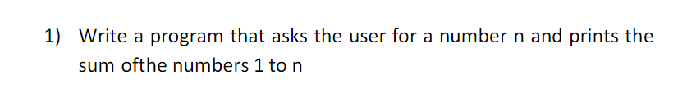

<!DOCTYPE html>

<html>

<body>

<h2>Sum of N numbers</h2>

<script>

const N= parseInt(prompt('Enter a positive integer: '));

let sum = 0, i = 1;

while(i <= N) {

sum += i;

i++;

}

document.write('The sum of N numbers:', sum);

</script>

</body>

</html>



<!DOCTYPE html>

<html>

<body>

<h2> Sum of multiples of 3 and 5 </h2>

<script>

const N= parseInt(prompt('Enter a positive integer: '));

let sum = 0, i = 1;

while(i <= N) {

if(i%3==0 || i%5==0){

sum += i;

}

i++;

}

document.write(''The Sum of multiples of 3 and 5 in N numbers is:'', sum);

</script>

</body>

</html>

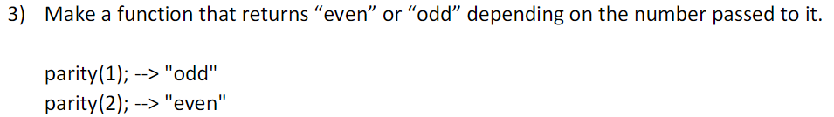

<!DOCTYPE html>

<html>

<body>

<h2>Even or Odd</h2>

<script>

const N= parseInt(prompt('Enter a positive integer: '));

if(N%2==0){

document.write("The given number is even");

}

else{

document.write("The given number is odd");

}

</script>

</body>

</html>

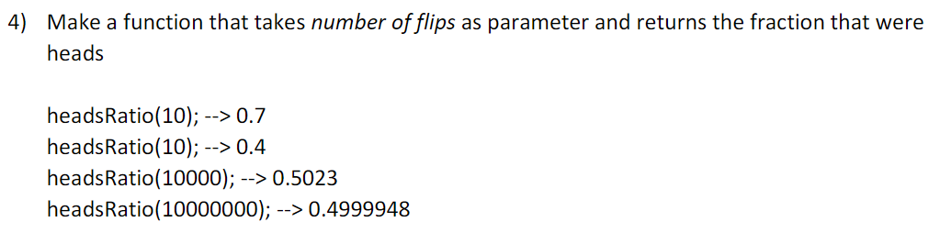

<!DOCTYPE html>

<html>

<body>

<h2>The fraction count of heads</h2>

<script>

function coinFlip() {

return(Math.random() < 0.3) ? 'Heads' : 'Tails';

}

const howManyTimes= parseInt(prompt('Enter the number of flips '));

var countHeads=0;

for (var i=0; i<howManyTimes;i++){

if (coinFlip()==='Heads'){

countHeads++;

}

}

document.write("Heads Ratio of "+(howManyTimes)+"-->"+(countHeads/howManyTimes));

</script>

</body>

</html>



<!DOCTYPE html>

<html>

<body>

<h2>20 Leap Years</h2>

<script>

const isLeap = year => {

return year % 400 === 0 || (year % 4 === 0 && year % 100 !== 0);

};

const nextNLeap = n => {

const arr = [];

let year = new Date().getFullYear()+1;

while(arr.length < n){

if(isLeap(year++)){

arr.push(year-1);

};

};

return arr;

};

document.write(nextNLeap(20));

</script>

</body>

</html>

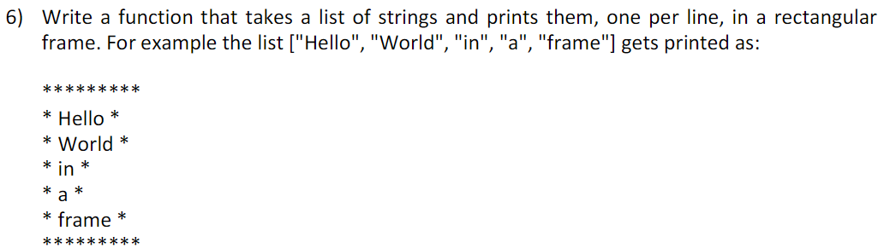

<!DOCTYPE html>

<**html** lang="en">

<**body**>

<**script** language="JavaScript">

function printList(list){

var list=[“Hello”,”World”,”in”,”a”,”frame”];

console.log(‘********’);

for(var I=0;i<list.length;I++){

Console.log(‘*’+list[I]+’*’);

}

printList();

}

</script>

</**body**>

</**html**>

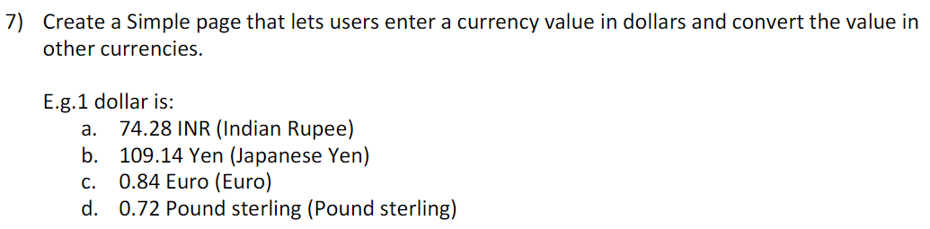

<!DOCTYPE html>

<html>

<body>

<script>

currency();

function currency()

{

var amt = prompt("Enter the value in dollars:");

document.write((amt*74.28)+" INR (Indian Rupees) <br>" + (amt*109.14)+" Yen (Japanese Yen) <br>" + (amt*0.84) + " Euro (Euro) <br>” + (amt*0.72)+ " Pound sterling (Pound sterling) <br>");

}

</script>

</body>

</html>



<!DOCTYPE html>

<html>

<body>

<h2>JavaScript Arrays</h2>

<p>The concat() method concatenates (joins) two or more arrays.</p>

<p id="demo"></p>

<script>

const arr1 = ["a", "b","c"];

const arr2 = ["1", "2", "3"];

const arr3 = arr1.concat(arr2);

document.getElementById("demo").innerHTML = arr3;

</script>

</body>

</html>

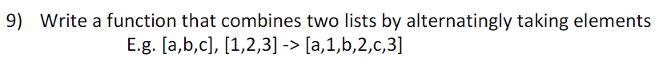

<!DOCTYPE html>

<html>

<head>

<title>Concatanate</title>

</head>

<body>

<script>

let a = [1,2,3];

let b = ['a', 'b', 'c'];

var newList = function(a,b)

{

let l = a.length+b.length;

let r = [];

let j=0,k=0;

for(let i=0; i<l;i++) {

if(i%2==0) {

r[i]=a[j++];

} else {

r[i]=b[k++];

}

}

return r;

}

document.write(newList(a,b));

</script>

</body>

</html>

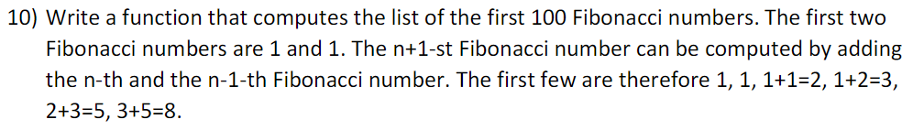

<!DOCTYPE html>

<html>

<head>

<title>Concatanate</title>

</head>

<body>

<script>

const number = parseInt(prompt('Enter the number of terms: '));

let n1 = 0, n2 = 1, nextTerm;

document.write('Fibonacci Series:');

for (let i = 1; i <= number; i++) {

document.write(n1);

nextTerm = n1 + n2;

n1 = n2;

n2 = nextTerm;

}

</script>

</body>

</html>



<!DOCTYPE html>

<html>

<body>

<script>

var a = [1,2,3,4,5];

a.reverse();

document.write(a);

</script>

</body>

</html>

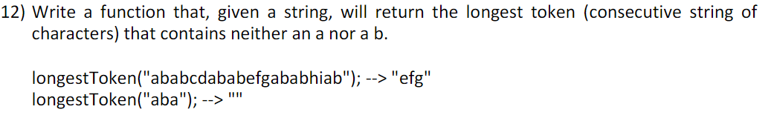

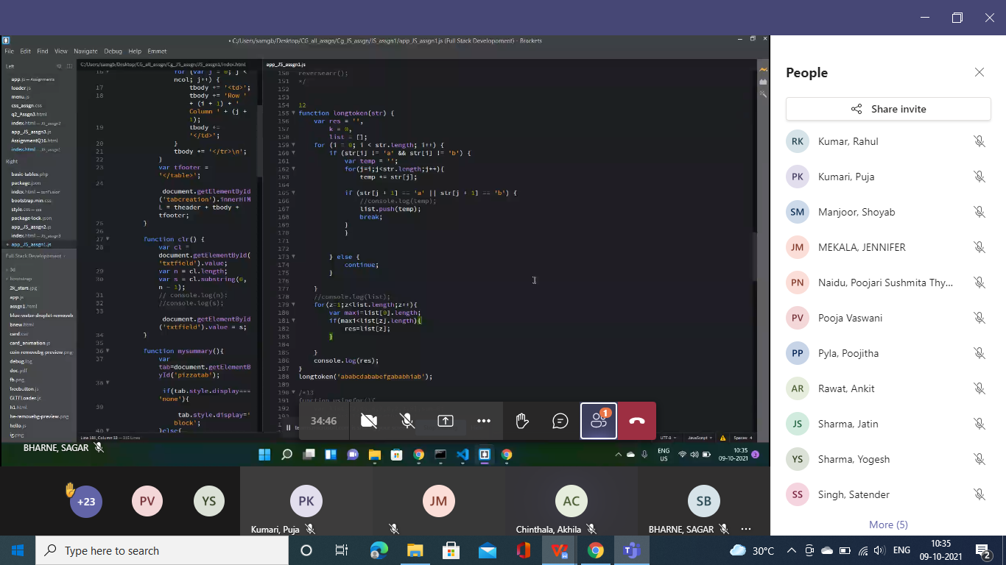

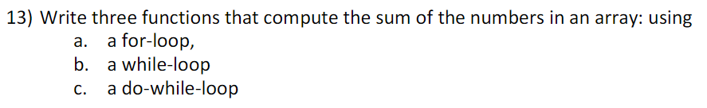

**While loop:**

<script>

var numbers = [10, 42, 5, 87, 61, 34, 99];

var i = 0;

var e = 0;

while(i <= numbers.length) {

e = e + numbers[i];

i++;

}

alert(e);

</script>

**For loop:**

<script>

var numbers = [10, 42, 5, 87, 61, 34, 99];

var e = 0;

for(I=0;i <= numbers.length;I++) {

e = e + numbers[i];

}

alert(e);

</script>

**Do-while Loop:**

<script>

var numbers = [10, 42, 5, 87, 61, 34, 99];

var i = 0;

var e = 0;

do{

e = e + numbers[i];

i++;

} while(i <= numbers.length)

alert(e);

</script>

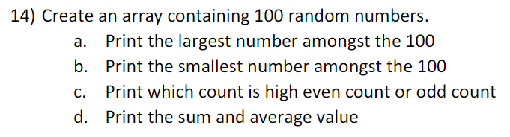

<html>

<body>

<script>

random();

function random()

{

var a = [5,15,17,65,100,46,1,24,-95,201,-5];

var max = Math.max(...a);

var min = Math.min(...a);

var ev,od,avg,sum=0;

for(i=0;i<a.length;i++)

{

sum +=a[i];

if(a[i]%2==0) ev++;

else od++;

}

document.write("maximum=" + max + " <br>minimum=" + min + "<br>sum=" + sum + "<br>average=" + sum/a.length+ "<br>");

if(ev>od)

document.write("Even");

else

document.write("Odd");

}

</script?

</body>

</html>

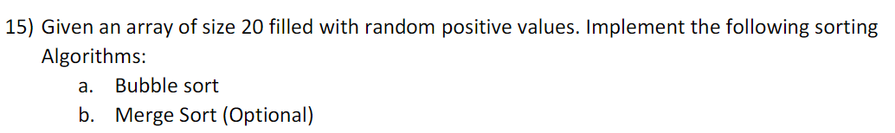

var inputArr = [];

while(inputArr.length < 20)

{

    var r = Math.floor(Math.random() * 100) + 1;

    if(inputArr.indexOf(r) === -1)  inputArr.push(r);

}

document.write(inputArr) ;

document.write("<br>") ;

lt bubbleSort = (inputArr) => {

    let len = inputArr.length;

    for (let i = 0; i < len; i++) {

        for (let j = 0; j < len; j++) {

            if (inputArr[j] > inputArr[j + 1]) {

                let tmp = inputArr[j];

                inputArr[j] = inputArr[j + 1];

                inputArr[j + 1] = tmp;

            }

        }

    }

    return inputArr;

}

document.write(inputArr) ;

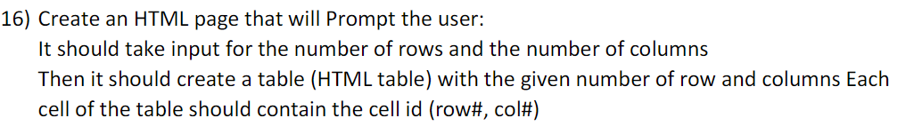

<!DOCTYPE html>

<html>

<head>

<meta charset=utf-8 />

<title>Create a table</title>

<style type="text/css">

body {margin: 30px;}

</style>

</head><body>

<table id="myTable" border="1">

</table><form>

<input type="button" onclick="createTable()" value="Create the table">

</form>

<script>

function createTable()

{

rn = window.prompt("Input number of rows", 1);

cn = window.prompt("Input number of columns",1);

for(var r=0;r<parseInt(rn,10);r++)

{

var x=document.getElementById('myTable').insertRow(r);

for(var c=0;c<parseInt(cn,10);c++)

{

var y= x.insertCell(c);

y.innerHTML="Row-"+r+","+" Column-"+c;

}

}

}

</script>

</body>

</html>

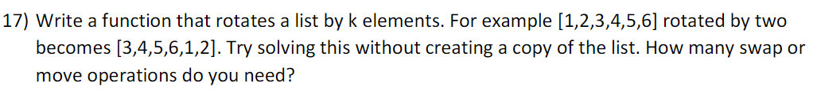

<!DOCTYPE html>

<!DOCTYPE html>

<html>

<body>

<h2>JavaScript Arrays</h2>

<p id="demo"></p>

<script>

const arr = [1,2,3,4];

var a=arr.shift();

arr.push(a);

document.getElementById("demo").innerHTML = arr;

</script>

</body>

</html>

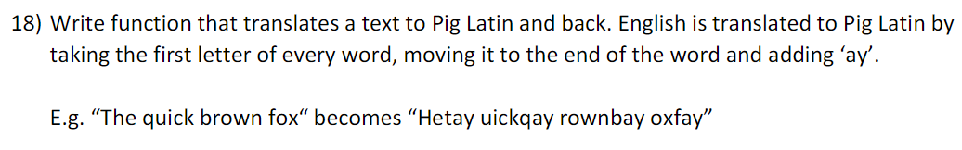

<!DOCTYPE html>

<html>

<head>

<title>Page Title</title>

</head>

<body>

<script>

var str="This is My Program";

function translatePigLatin(str) {

let vowels = ['a', 'e', 'i', 'o', 'u'];

let newStr = "";

if (vowels.indexOf(str[0]) > -1) {

newStr = str + "way";

return newStr;

} else {

let firstMatch = str.match(/[aeiou]/g) || 0;

let vowel = str.indexOf(firstMatch[0]);

newStr = str.substring(vowel) + str.substring(0, vowel) + "ay";

return newStr;

}

}

</script>

</body>

</html>

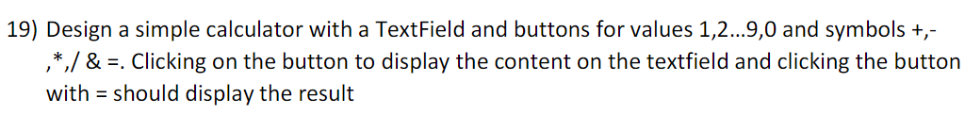

<!DOCTYPE html>

<html lang = "en">

<head>

<title> JavaScript Calculator </title>

<style>

h1 {

text-align: center;

padding: 23px;

background-color: skyblue;

color: white;

}

#clear{

width: 270px;

border: 3px solid gray;

border-radius: 3px;

padding: 20px;

background-color: red;

}

.formstyle

{

width: 300px;

height: 530px;

margin: auto;

border: 3px solid skyblue;

border-radius: 5px;

padding: 20px;

}

input

{

width: 20px;

background-color: green;

color: white;

border: 3px solid gray;

border-radius: 5px;

padding: 26px;

margin: 5px;

font-size: 15px;

}

#calc{

width: 250px;

border: 5px solid black;

border-radius: 3px;

padding: 20px;

margin: auto;

}

</style>

</head>

<body>

<h1> Calculator Program in JavaScript </h1>

<div class= "formstyle">

<form name = "form1">

<input id = "calc" type ="text" name = "answer"> <br> <br>

<input type = "button" value = "1" onclick = "form1.answer.value += '1' ">

<input type = "button" value = "2" onclick = "form1.answer.value += '2' ">

<input type = "button" value = "3" onclick = "form1.answer.value += '3' ">

<input type = "button" value = "+" onclick = "form1.answer.value += '+' ">

<br> <br>

<input type = "button" value = "4" onclick = "form1.answer.value += '4' ">

<input type = "button" value = "5" onclick = "form1.answer.value += '5' ">

<input type = "button" value = "6" onclick = "form1.answer.value += '6' ">

<input type = "button" value = "-" onclick = "form1.answer.value += '-' ">

<br> <br>

<input type = "button" value = "7" onclick = "form1.answer.value += '7' ">

<input type = "button" value = "8" onclick = "form1.answer.value += '8' ">

<input type = "button" value = "9" onclick = "form1.answer.value += '9' ">

<input type = "button" value = "*" onclick = "form1.answer.value += '*' ">

<br> <br>

<input type = "button" value = "/" onclick = "form1.answer.value += '/' ">

<input type = "button" value = "0" onclick = "form1.answer.value += '0' ">

<input type = "button" value = "." onclick = "form1.answer.value += '.' ">

<input type = "button" value = "=" onclick = "form1.answer.value = eval(form1.answer.value) ">

<br>

<input type = "button" value = "Clear All" onclick = "form1.answer.value = ' ' " id= "clear" >

<br>

</form>

</div>

</body>

</html>

